Entry Process NHS Chef 2025
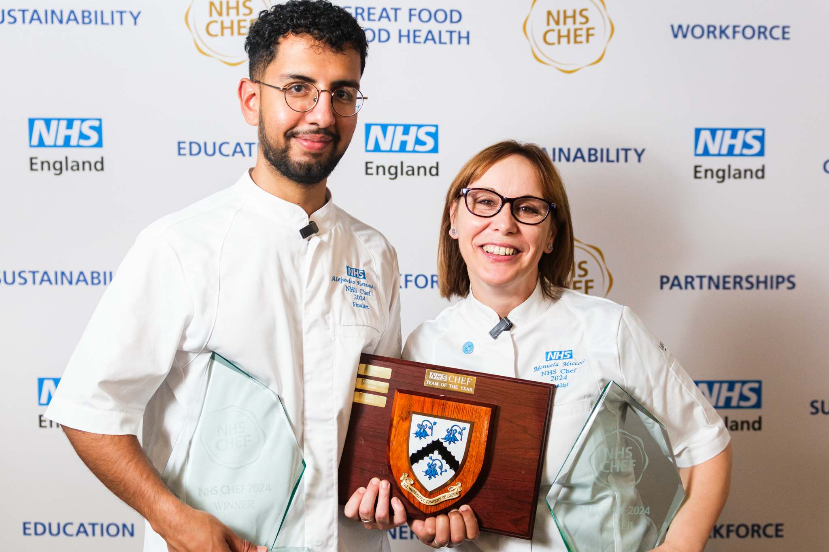

Step 1 Apply for NHS Chef 2025
You will be required to produce a three-course meal within a budget of between £6-£8 The whole menu must be lower in carbon and recipes will have to be emailed in to england.greatnhsfood@nhs.net to work out the carbon footprint prior to cooking.
One course must be completely allergen free, and one course has to be plant based, we are unable to use any form of Nut throughout the competition. The main course must have a minimum of 26g protein per portion, this can include fish, meat or other items and must be served hot. The dessert should be based on 50% fruit content (hot or cold).
Step 2 Submit Your Entry
Submit your entry at england.greatnhsfood@nhs.net clearly marked NHS Chef 2025. Entries must be received no later than 20th June 2025.
Step 3 Paper Judging
Judges will review all entries to confirm their suitability and align with competition rules. There are up to 8 teams who will qualify for the finals. Due to the number of contestants anticipated, verbal feedback will be given at the end of each regional session, the judges decisions will be final. One team from each region will automatically qualify for the final with the scores being totalled up for the remaining places. The remaining teams will find out no later than 13th August to understand if they have been successful.
Step 4 Regional Heats
Regional heat competitors will be advised via email, if successful. Regional heats will be held in 5 locations across the country in July and August 2025, see Table 1. Judges reserve the right to change the venues.

Table 1: Regional Heats Location and Dates
Venue | Region | Date
University of West London UWL, Pillars Kitchen and Restaurant, St Marys Road, Ealing, W5 5RF | London | 8th & 9th July 2025
Newcastle, Lifestyle Academy Newcastle College, Rye Hill Campus, Scotswood Road, Newcastle upon Tyne, Tyne and Wear, NE4 7SA | Northeast | 1st July 2025
Manchester Trafford College, Manchester Rd, West Timperley, Timperley, Altrincham WA14 5PQ | Northern | 2nd July 2025
The Food Works SW, Whirlwind Rd, Weston-Super-Mare BS24 8EF | Southwest | 12th August 2025
Edgbaston Cricket Ground, Edgbaston Road, Edgbaston, Birmingham, B5 7QU | Midlands | 13th August 2025

Competitors will be expected to travel to the chosen location for their regional Heat . No funding is available for travel expenses or hotel accommodation.
Competitors must provide all ingredients, knives, light equipment, or speciality equipment. Crockery will be provided for the food to be served on. It should be noted that all food will be presented on the plates provided.
Competitors should be aware that there is the potential for both regional and national heats to be filmed and all entrants will need to sign a GDPR form.
This will allow the use of their image and information in promoting the event.
At the regional event you will be required to provide a breakdown of the cost of all ingredients used in the starter, main course, and dessert. You will also be required to evidence the dishes nutritional value and a supply menu card.

Step 5 Mentoring Event
To prepare all contestants for the Final a Mentoring Event will be held on the 16th 17th and 18th September 2025) in Cannock. The event will last 3 days and cover a range of topics. Guest speakers will inform contestants on key topics. The expectation is that qualification for the final, means that you will need to be available for the full 3 days. We aim to offer anyone who enters the competition the chance of attending a training session at our mentoring event on the 17th September, lunch will be provided but it will be up to the trust to organise the teams travel, catering mangers are also welcome.
Step 6 Final
The 8 finalists will compete in the final arriving in York on 19th October starting on the 20th to 24th October. In the event of a regional finalist withdrawing or being unable to attend the competition, the place will be offered to the next highest place team from the regional heats.
Note – Within the competition all recipes created, will be used on the National food platform, it is essential that you keep your recipes and are able to submit these at the end of the competition. A template will be provided to be used for all recipes
If you have any queries, please contact england.greatnhsfood@nhs.net with “NHS Chef 2025” in the title.
